**CHAPTER-1   
                                                           INTRODUCTION**

CRM stands for “customer relationship management” and its software that stores customer contact information like names, addresses, and phone numbers, as well as keeps track of customer activity like website visits, phone calls, email, and more

**1.1 Why CRM matters?**

* CRM helps you ditch clunky processes and manual effort so you can get on with business.
* You’ll find more leads, close more deals, keep more customers and grow your business.
* One place to store all customer information means your conversations are always personal, relevant, and up to date.
* Salesforce customers report 37% more sales revenue, 45% higher customer satisfaction, 43% better marketing ROI*.

System may be defined as a layered structure that depicts how programs involved would interrelate and communicate. In computers, System may also include actual programs, programming interfaces and tools for managing the larger system. The term system may be used differently in different contexts, but more or less the concept remains the same. Real Estate CRM provides multiple services related to real estate services. This application consists of multiple modules, which further contain different systems along with the implementationof their defined constraints.  
Basically, systems are implemented for providing simple manual processes and that is exactly what we are trying to achieve. System is implemented as per user requirement such as a manufacturing concern may install a plant for easing out manual processes. We have sought help from computer programming for automation of manual registration system. With the introduction of computers, every aspect of our lives has been revolutionized. When used judiciously, computers can help us save time, secure our personal information, access the required information whenever and wherever required. Keeping all these positive points in mind, we have developed a Real Estate CRM for easily providing the services facilities for the student in an application.

**1.2 What is cloud computing?**

Cloud computing is the delivery of on-demand computing services -- from applications to storage and processing power -- typically over the internet and on a pay-as-you-go basis. From 2016, software-as-a-service (SaaS) in the cloud is set to support the majority of deployments.

At the same time, a specialist cloud supplier, Salesforce.com, has become the largest player in the CRM market, in value terms, according to Gartner. Although most of the major suppliers of on-premise CRM also provide solutions hosted in the cloud, differences in heritage, product features and architecture are important when businesses come to selecting the right tools to help them interact with existing – and potential – customers.

Every CRM solution should provide a set of basic features which support its implementation across a number of specific business requirements. Contact management provides a way to manage prospects, leads, clients, and other important contacts, all from one place.

**1.3 How does cloud computing work?**

Rather than owning their own computing infrastructure or data centres, companies can rent access to anything from applications to storage from a cloud service provider.

One benefit of using cloud computing services is that firms can avoid the upfront cost and complexity of owning and maintaining their own IT infrastructure, and instead simply pay for what they use, when they use it.

In turn, providers of cloud computing services can benefit from significant economies of scale by delivering the same services to a wide range of customers.

**Cloud computing advantages and disadvantages:**

Cloud computing is not necessarily cheaper than other forms of computing, just as renting is not always cheaper than buying in the long term. If an application has a regular and predictable requirement for computing services it may be more economical to provide that service in-house.

Some companies may be reluctant to host sensitive data in a service that is also used by rivals. Moving to a SaaS application may also mean you are using the same applications as a rival, which may make it hard to create any competitive advantage if that application is core to your business.

While it may be easy to start using a new cloud application, migrating existing data or apps to the cloud may be much more complicated and expensive. And it seems there is now something of a [shortage in cloud skills](https://www.zdnet.com/article/employers-well-boost-pay-and-some-training-for-cloud-computing-skills/) with staff with DevOps and multi-cloud monitoring and management knowledge in particularly short supply. In one recent report a significant proportion of experienced cloud users [said that they thought upfront migration costs](https://www.zdnet.com/article/cloud-computing-migration-more-expensive-and-complicated-than-you-thought/) ultimately outweigh the long-term savings created by IaaS. And of course, you can only access your applications if you have an internet connection.

**Detailed Problem Definition:**

**EXISTING SYSTEM**

There are lots of problem to Selling rooms, apartments, offices, houses for a single time. The main problem is that the wasted of time to find suitable property in the specific area or surroundings. We also do so many efforts to find right buyer or seller. These are so many problems.

**DRAWBACK OF EXISTING SYSTEM**

•Lack of time – It becomes a problem in itself to find services of buying and selling rooms, apartments, offices, houses in busy life of a human being.

•More efforts – For searching these services we do lots of efforts and don’t have surety to find out service providing man.

•Bargaining – After successful searching it demands money according to their wish and there is no fix price.

**PROPOSED SYSTEM**

The Admin have all the type of authority. The Admin maintain property. Admin identify property type as it is residential or commercial property or offices. The Admin user can inform their agents for regarding to property and update the information regarding property and cancellation of property or changing buyer choice. The user should book the property for sell or rent with detail of property. The system is very useful for the companies or builders that can post and edit their properties and their personal info and admin can monitor records of all of them. The system is also useful which also keeps track of Account details of buyers and Investors.

**CHAPTER-2**

**REQUIREMENT ANALYSIS**

**2.1 SYSTEM REQUIREMENTS**

The Salesforce online application can run on any computer with an Internet connection and supports the following browsers: Browser Comments Chrome applies updates automatically. Salesforce makes every effort to test and support the most recent version. There are no configuration recommendations for Chrome. Google Chrome, most recent stable version Salesforce makes every effort to test and support the most recent version of Firefox. Mozilla® Firefox, most recent stable version If you use Internet Explorer, we recommend using the latest version that Salesforce supports. Apply all Microsoft software updates. Microsoft Internet Explorer versions 9, 10, and 11 there are no configuration recommendations for Safari. Apple Safari versions 5.x, 6.x and 7.x on Mac OS X Note: For all browsers, enable JavaScript, cookies, and TLS 1.2. If TLS 1.2 isn’t available, enable TLS 1.1. Browsers that don’t support TLS 1.1 or TLS 1.2 won’t be able to access Salesforce after we deactivate TLS 1.0. Deactivation has already occurred in sandbox orgs and concludes with production orgs on July 22, 2017. Some features in Salesforce—and some desktop clients, toolkits, and adapters—have their own browser requirements.

**2.2NEED FOR THE NEW SYSTEM**

This is an Online real estate CRM through which a user can access its information and manage all the adding, updating, deleting the assets and some of its tasks.

The Admin user can change the update the information regarding property selling and buying and cancellation. The system is very useful for the companies who develops apartments, hotels, villa, residential properties and commercial properties. Companies or individual agents can also advertise their property. It is a cloud application for the online servicing which can be used for providing home-based services for proving it for usage by all the people means to use it at any moment and at any time from any place. The project serve administrator to view the details of all users and maintain their database in an efficient and effective manner so that their maintenance will be easy.

The services provided to the users are view of the contact details of a course, related to their need and along with their services. Users can check here service charges related to particular service.

The benefits desired would be more than the cost of computerization in terms of increased business, better controls & fix prize of services. From the description of the present system & problems with the existing system one can gauge the manpower wasted in these activities even then it’s difficult to gain access it. Addition, updating, modifying and deleting records is very easy in the Business Generation system. Just on the click of fingers different data can be accessed. So, here lies the need for a change from the old age system.

**1.3 Project Scope**

The real of CRMhave spread across millions of households, so naturally, Internet has become by far the best platform for real estate marketing today. Now a days when everything is online, how is it possible that real estate left web application behind? There are lots of real estate companies who advertise their property online so idea behind developing this application is that their property can also sell, or buy or even rent property using this. These applications are not widely popular but in future, they have large scope of growth. This CRM is an online real estate management through which individual agents or buyer can maintain their property document keeping and managing property registration and also access its information and manage all the adding, updating, deleting the ads and some of its tasks. The Admin user can inform their agents for regarding to property and update the information regarding property and cancellation of property or changing buyer choice.

The system is very useful for the companies or builders that can post and edit the information of their properties and their personal info and admin can monitor records of all of them. The system is also useful which also keeps track of Account details of buyers and Investors.

**CHAPTER-3**

**FEASIBILITY STUDY**

A Feasibility Study determines whether a project is worth doing. The process followed for making this determination is called a Feasibility Study. This type of study determines whether a project can and should proceed. Once it has been determined that a project is feasible, the analyst can proceed and prepare the project specifications that finalize the project specification. The following are the various types of feasibility studies that can be undertaken.

**3.1 Technical Feasibility:**

This is concerned with specifying the equipment and the software to satisfy the user requirements. The technical needs of the system vary considerably but might include:

* The facility to produce outputs in a given time.
* Response time under certain conditions.
* Ability to process a certain volume of transactions at a specified speed. Facility to communicate data to a distant location.

Technical feasibility centers on the existing computer system, hardware, software etc and to what extent it can support the system. In examining the technical feasibility, the configuration of the system is given more importance than the actual hardware. The configuration should provide the complete picture of the system requirements, for example how many workstations are required and how these units are interconnected so that they would operate smoothly, etcetera. The result of the Technical Feasibility Study is the basis for the documents against which dealer and manufacturer can make bids. Specific hardware and software products can then be evaluated keeping in view the logical needs. This approach helped to understand how to re-use these options in a better way, and the kind of customization required. It also helped to unveil the problems in implementing these systems. The study was then focused on the new technology that could eliminate these problems and also have a futuristic approach to serve the stakeholders on a large scale. Cloud computing technology was studied in detail as a solution to the problem. Feasibility to re-use existing blocks and integrate them on the cloud platform was the primary focus of the technical study.

SOA approach was adopted to implement the same. The final technical framework was again studied with two approaches based on the cloud platform. The frame work of best feasible solution is described.

**3.2 Economic Feasibility:**

Economic analysis is the most frequently used method for evaluating the effectiveness of a new system. More commonly known as cost/benefit analysis, the procedure is to determine the benefits and savings that are expected from a candidate system and compare them with costs. If benefits outweigh costs, then the decision is made to design and implement the system. It is not done to analyze the new system. Using a Gantt Chart schedule and part chart. We assumed that the benefit of the project is greater than the cost. So if we can develop the project easily then it is used for the evaluation of the proposed. We calculate the cost/benefit analysis and we assume that the benefit is feasible so we start developing the project. It is an analysis of the cost to be incurred in the system and benefits the derivable from the system. An economic Feasibility Study should demonstrate the net benefit of the proposed course of action in the context of direct and indirect benefits and costs to the organization and to the public as a whole. It should be required for both pilot and long-term activities, plans and projects.

**3.3 Operational Feasibility:**

It determines how acceptable the software is within the organization. The evaluations must then determine the general attitude and skills. Such restriction of the job will be acceptable. To the users are enough to run the proposed budget, hence the system is supposed to the feasible regarding all except of feasibility. In operational feasibility, we attempt to ensure that every user can access the system easily. We develop a menu that users can easily access and we provide shortcut keys. We show a proper error message when any mistakes are made in the program. We provide help and a guideline menu to help the user. Changes in the ways individuals are organized into groups may then be necessary and the groups may now compete for economic resources with the needs of stabilized ones by converting a number in a file in software.

**3.4 Behavioral Feasibility:**

Normal human psychology of human beings indicates that people are resistant to change and computers are known to facilitate change. Any project formulations should consider this factor also. Before the development of the Project titled "Real Estate CRM", the need to study the feasibility of the successful execution of the project was felt and thus the following factors are considered for a Feasibility Study. Need Analysis. Provide the users information pertaining to the preceding requirement.

**3.5 Feasibility Study Report:**

* The result of the Feasibility Study provides us with the following facts:
  + The automated system would increase the efficiency of the system.
  + The automated system would increase customer's satisfaction.
  + The automated system has many requirements such as Efficiency cost effectiveness, prompt service, Reliability.
  + The automated system would add to the security features of the system
  + The automated system should be simple to use, incorporate all necessary services and maintainable.
  + This will cause some changes in the organization. These are:
* Change in staffing policies: present employees will need to be sent for training.
* New employees to be recruited will need to have the knowledge of the Salesforce system.

**CHAPTER-4**

**TECHNOLOGY USED**

**About Salesforce:**

Salesforce is the world’s #1 customer relationship management (CRM) platform. It is cloud-based, CRM applications for sales, service, marketing, and more don’t require IT experts to set up or manage — simply log in and start connecting to customers in a whole new way. Salesforce began with the vision of reinventing Customer Relationship Management (CRM). Since then it has changed the way enterprise software is delivered ad used, changing the industry forever. All Salesforce products run entirely in the cloud so there’s no expensive setup costs, no maintenance and your employees can work from any device with an internet connection – smartphone, tablet or laptop.

It makes CRM easy to use for small businesses and large-scale enterprises. This approach has helped to make Sales Cloud the world’s number 1 CRM system. But Salesforce doesn’t start and end with CRM for Sales and Marketing. This platform enables you to manage all interactions with your customers and prospects, so your organization can grow and succeed. That’s why it is called as the Customer Success Platform.

Customer Relationship Management (CRM) is most commonly used to manage a business-customer relationship. CRM software systems are also used in the same way to manage business contacts, employees, clients, contract wins and sales leads.

CRM is a sound business strategy to identify the bank's most profitable customers and prospects, and devotes time and attention to expanding account relationships with customers through individualized marketing, repricing, discretionary decision making.

Salesforce CRM totally behaves and work like a software. Salesforce is rigid, transparent,quick, user friendly and most important of all secure. Salesforce creates a connection between its customer’s and the business.

In Salesforce we have Data modelling to store and manage the data and the U/I very user friendly and easy.

**4.2 Schema Builder:**

Schema Builder provides a dynamic environment for viewing and modifying all the objects and relationships in an app. This greatly simplifies the task of designing, implementing, and modifying the data model, or schema.

It can be used to view existing schema and interactively add new custom objects, custom fields, and relationships, simply by dragging and dropping. This eliminates the need to click from page to page to find the details of a relationship or to add a new custom field to an object in the schema.

Schema Builder provides details such as the field values, required fields, and how objects are related by displaying lookup and master-detail relationships. The fields and relationships can be viewed for both standard and custom objects.

Schema Builder is enabled by default and lets administrators add the following to the schema:

▪Custom Objects

▪Lookup Relationships

▪Master-detail relationships

▪All custom fields except: Geolocation

You can also create objects using Schema Builder. If you prefer, you can create objects in this visual interface if you’re designing your system and want to be able to revise all your customizations on the spot. Let’s see how it’s done.

1. In the left sidebar, click the ​**Elements**​ tab.

2. Click ​**Object**​ and drag it onto the canvas.

3. Enter information about your object. You can make it whatever you want!

4. Click ​**Save**​.

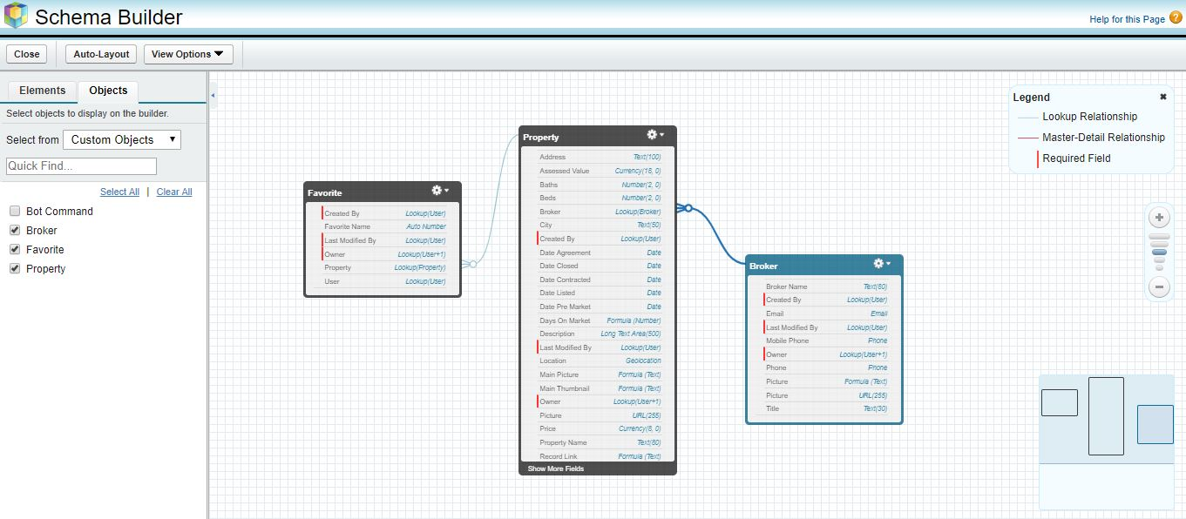

**Figure 4.1 Schema Builder of Real State CRM**

**4.3 Lead:**Lead object is used to store information about a person interested in the product or service we are delivering. In business terms leads are the people who are your potential customers.   
Leads are prospects who’ve expressed interest in our product but aren’t qualified to buy it, hence they can also be called as an unqualified prospect.

**Lead Conversion:**

Lead conversion is a process in which a lead record is converted into Accounts, Contacts & Opportunities. This happens when a lead is identified as a qualified Sales prospects.

When a lead is converted

• A contact, account & opportunity are created and populated with the lead’s data (unless otherwise specified during conversion).   
• The lead field “Converted” is changed from false to true.

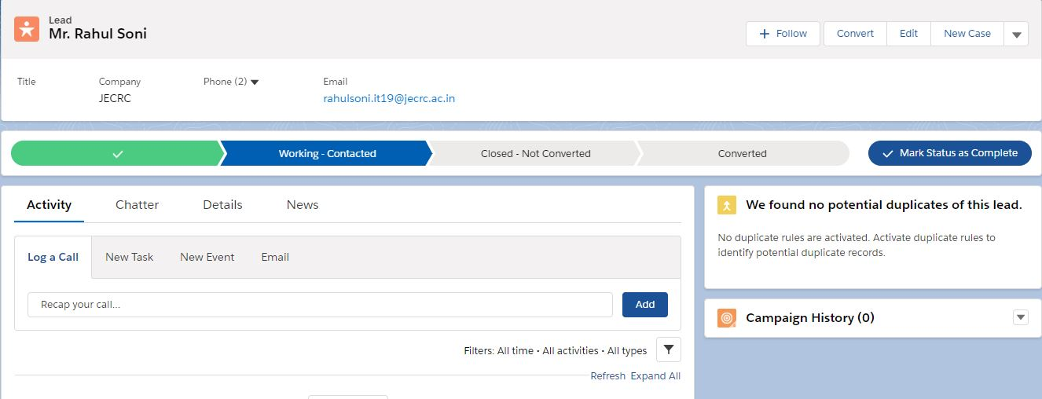

**Figure 4.1 Lead Created**

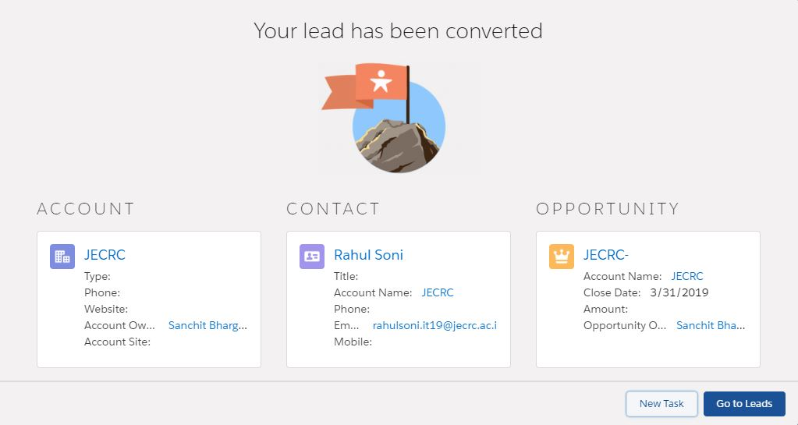

**Figure 4.2 Lead Converted**

**4.3 Object:**Salesforce supports several different types of objects. There are standard objects, custom objects, external objects, platform events, and Big Objects.The primary object in the Salesforce data model represents accounts/companies and organizations involved in the business, such as customers, partners, and competitors. A record is similar to a row in a database table.

**Standard objects**​ are objects that are included with Salesforce. Common business objects like Account, Contact, Lead, and Opportunity are all standard objects.

**Custom objects**​ are objects that you create to store information that’s specific to your company or industry.

Objects are containers for your information, but they also give you special functionality. For example, when you create a custom object, the platform automatically builds things like the page layout for the user interface.

**Created the custom object Brands in the following way,**

* Click on Create Objects Custom Object.
* Enter the Label name as Brand, Plural name as Brands which be used as Tab name and Object name as Brand which will be used as API name. By default, the custom objects are stored with __c to access through API.
* Enter the record name Brand Title which is a mandatory field while creating a custom object and select its data type as Text.
* Next, check allow reports, activities and track field history check box fields, which are basically for availing report creation, assigning tasks to the user for a particular Brand record and tracking the history of all field edits and updates.

In similar fashion, For the Real State CRM, three custom objects were created.

**1. Property:**

Custom objects are objects that you create to store information that’s specific to yourcompany or industry.

For Real Estate CRM, we want to build a custom Property object that stores photos and information about properties that are on the market.

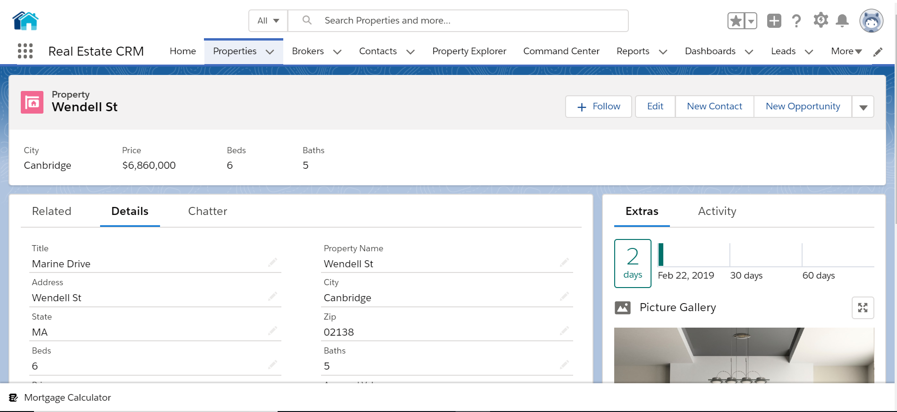

**2. Broker:**

Broker is another Custom Object that we have in Real Estate CRM.

Broker Object stores the information of different partner brokers who connect with customers to sell the property in the market.

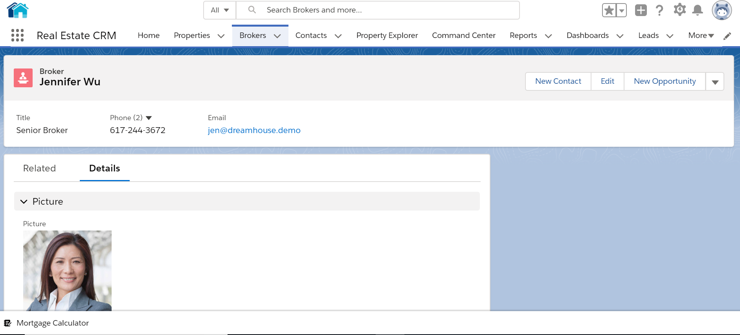

**3. Favourite:**

Favourite is another Custom Object that we have in Real Estate CRM.

Favourite Object stores the information of customers that have favorited a particular property.

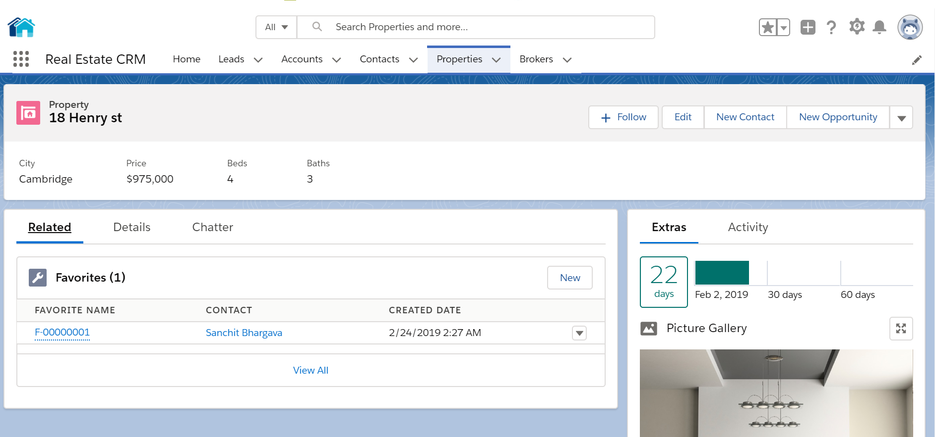

**4.4 Fields**

Salesforce has provided many inbuilt fields called standard fields like “Name,” “Owner,” “Created By,” “Last Modified By” etc. Every object in Salesforce has a set of standard fields that may be applicable for capturing data for that type of an object.

Salesforce also allows users to create new fields in the system to capture additional information. These fields are called as custom fields. Salesforce supports a variety of datatypes for these fields like Text, Text Area, Rich Text Area, Number, Currency, Boolean, Email, Phone, etc.

Administrators can then configure how these fields should be set (visible/read only/edit/mandatory).

Created some more custom fields to the object Brand in the following way,

* Create Objects Brand Custom Fields & Relationships**.**

**4.5 Relationships:**

The Force.com platform supports two types of parent-child relationships between objects. They are lookup relationships and master-detail relationships. These relationships connect objects with other objects. These both work like a foreign-key relationship in a relational database. These relations are the fields in the Salesforce. We can create them as we create custom fields.

**The lookup relationship** creates a simple relation between two objects. With this relationship field, we can navigate from records in one object to the related records in another object and can create one-to-one and one-to-many relationships. Lookup relationships are appropriate when a relationship between two objects is required in some cases, but not always. In scenarios like to relate multiple parent records to the child record and to reference commonly shared data, such as reference data, a lookup relationship is used.

**The master-detail relationship** is a powerful relationship which is based on a parent-child relationship. The object on which we create a master-detail relationship is the child, and the other one is the parent or master object which will be referenced as a field in the child object. The sharing settings of the child object can be taken from their master object. In a master-detail relationship, if we delete master object records, child objects also automatically deleted. With the master-detail relationship, we can create a roll-up summary field on parent objects.

**4.5 Securing and Sharing data:**

Salesforce provides a wide level of security and sharing of data in an organization. Some of them are listed below.

1. Object Level Access: These controls access to objects in the Organization.

2. Field Level Access: These controls access to particular fields in an object.

3. Record Level Access: These controls access to the records of an Object.

4. Profiles: Every user has one profile and this profile is used to control many things like user permissions, object permissions, field permissions, app settings, tab settings, Visualforce page access, Apex class access, page layouts, login hours, and login IP ranges and so on.

5. Permission Sets: Every user can have one profile but can have multiple permission sets. Permission sets to control access of object permissions, field permissions, user permissions, tab settings, app settings and it also controls Apex class access and Visualforce page access.

6. Field Level Permissions: These controls access of a user to view, edit and delete of fields of an object.

7. Organization-Wide Default Settings: These are default controls set by the organization and these controls access to the records of an object.

8. Role Hierarchies: With this, the user who is above in the role hierarchy will have access to the records of their subordinates.

9. Sharing rules: These controls access to the records of an object but these makes exceptions to the organization-wide default.

10. Manual sharing: It overrides the all the restrictions to access the records. One can share records with specific users.

The profile and the user permissions restrict what the user can see. The modifications made in the desktop Salesforce site are reflected in the app even and mobile users to get their Organization's data without special configuration.

**4.6 Page Layouts:**

Page Layouts can be used to control the visibility of the custom fields, button and links on the Object record. We can rearrange the fields as per our convenience and by separate sections also. We can make a field to be visible, required or read-only field to control the access for different users, marks few fields as read only, mark few fields as mandatory, etc. Page layouts can be created in the following way,

Create Objects (Custom Object) Page Layouts

**4.7 Visual Force:**

Visualforce is a complete framework for making such UIs, empowering any interface outline and communication to be constructed and conveyed altogether in the cloud. The UIs that work with Visualforce can expand the standard Force.com stage look and feel, or supplant it with an impressive style and set of sophisticated interactions. Since Visualforce markup is rendered into HTML, designers can utilize Visualforce tags along with standard HTML, JavaScript, Flash, or whatever other code that can execute inside an HTML page on Platform. Visual Force pages can enable in the mobile by just checking the “ enable the page for mobile apps” box field after creating it. With the CSS, the visual force pages can be optimized for the mobile devices and match the look of the Salesforce1.

For the Inventory Management app, more than 10 VF pages are created. The log in page, the home page, manage the product page, the insert product page, the invoice page and the payment page, are some of them.

**4.8 Apex:**

Salesforce introduced Apex as the first cloud computing programming language. The syntax of Apex is quite similar to Java. It is particularly intended for building business applications to oversee Data and procedures larger ambiance of the Force.com platform. The Apex lets the developers focus just on elements specific to their application by providing a productive approach to creating functionality and logic, leaving the rest of work for Force.com Platform.

Usually, for every interactive VF page, Apex Class is associated. So more 10 Apex Classes are used in the Application.

**4.9 Reports and Dashboards:**

As we know a company deals with lots of data, to check the data record by record is a very lengthy and time taking process. A good application should provide the overview of the data at a glance. For this purpose, Salesforce provided a tool called Reports. Using reports, we can generate different formats of data resides in the company at a glance view. A dashboard is a place where we can put all reports together to give the overview of the statistics. For example, if the manager wants to know how many products are sold from the inventory, he can create reports and find these statistics. Salesforce supports four different formats of Reports which are,

* Tabular Reports: These give a simple list view of data with Grand totals. But these are not used to create groups of data and graphs.
* Summary Reports: These give the summary of the data like subtotals with row-wise also. These are used to create charts, graphs. These reports can be used in the dashboard.
* Matrix Reports: These give the groups of data both by row wise and column wise. These are the most time consuming to generate a report or to set up, but can also be used in the dashboard.
* Joined Reports: These allow to join the multiple reports of different types. These reports can also be used to create charts so that can be used in dashboards.

The Reports can be created as follows,

* Create Apps Add Reports Tab Reports.

A Dashboard can show the reports in a visual format like Charts, Gauges, Tables, Metrics, or Visualforce pages. Force.com platform supports 20 components to be allowed in a dashboard for an organization. For example, the reports which we created before, like Pie chart and Vertical bar chart we can put up to 20 components in a dashboard. For the dashboard also we created a folder and saved all the dashboards under Inventory Dashboards folder and shared same as Reports folder. Dashboard can be created as,

* Reports Tab Reports & Dashboards New Dashboard

**CHAPTER 6**

**UML DIAGRAMS**

**6.1 SOFTWARE DEVELOPMENT LIFE CYCLE:**

A system development life cycle is a logical process by which system analysts, software engineers, programmers, and end users build information systems and computer applications to solve business problems and needs. The major phases involved in the MIS development process are referred to as system development life cycle. Each phase of the development process must have well defined objectives, and at the end of each phase, progress towards meeting the objectives must be evaluated. The development process should not continue until the objectives of all prior phases have already met.

System development life cycle is a phased approach to analysis and design to ensure that systems are best developed.

**6.2 USE CASE DIAGRAMS**

Use-cases model the system from the end-user’s point of view. Created during requirements elicitation, use-cases should achieve the following objectives:

* To define the functional and operational requirements of the system (product) by defining a scenario of usage that is agreed upon by the end-user and the software engineering team.
* To provide a clear and unambiguous description of how the end-user and the system interact with one another.

During OOA, use-cases serve as the basis for the first element of the analysis model. Using UML notation, a diagrammatic representation of a use-case, called a use-case diagram, can be created. Like many elements of the analysis model, the use-case diagram can be represented at many levels of abstraction. The use-case diagram contains actors and use-cases.

Actors are entities that interact with the system. They can be human users or other machines or systems that have defined interfaces to the software.

**6.3 DATA FLOW DIAGRAM**

The data flow diagram is also known as “bubble chart” has the purpose of clarifying system requirements and identifying major transformations that will become programs in system design so it is the starting point of specification down to the lowest level of detail. A DFDs consists of a series if bubbles joined by lines. The bubbles represent data transformation and the lines represent the data flow in the system.

**CHAPTER 7**

**TESTING METHODOLOGY**

**7.1 TESTING:**

The implementation phase of software development is concerned with translating design specification into source code. The preliminary goal of implementation is to write source code and internal documentation so that conformance of the code to its specifications can be easily verified, and so that debugging, testing and modifications are eased. This goal can be achieved by making the source code as clear and straightforward as possible. Simplicity, clarity and elegance are the hallmark of good programs; obscurity, cleverness, and complexity are indications of inadequate design and misdirected thinking. Source code clarity is enhanced by structured coding techniques, by good coding style, by, appropriate supporting documents, by good internal comments, and by feature provided in modern programming languages.

Testing is the set of activities that can be planned in advance and conducted systematically. Numbers of testing strategies are proposed. All provide software developer with a template for testing and all have following characteristics.

* Testing begins at component level & works “outward” towards the integration of the entire computer-based system.
* Different testing techniques are appropriate at different points in time.
* Testing is conducted by the developer of the software & independent test group.
* Testing & debugging are different activities, but debugging must be accommodated in any testing strategy.

**7.2 TEST PLAN:**

#### 7.2.1 Unit Testing:

It focuses on smallest unit of software design. In this we test an individual unit or group of interrelated units. It is often done by programmer by using sample input and observing its corresponding outputs.

#### 7.2.2 Integration Testing:

#### The objective is to take unit tested components and build a program structure that has been dictated by design. Integration testing is testing in which a group of components are combined to produce output.

#### 7.2.3 Regression Testing:

Every time new module is added leads to changes in program. This type of testing makes sure that whole component works properly even after adding components to the complete program.

#### 7.2.4 Smoke Testing:

This test is done to make sure that software under testing is ready or stable for further testing. It is called smoke test as testing initial pass is done to check if it did not catch the fire or smoked in the initial switch on.

#### 7.2.5 Alpha Testing:

This is a type of validation testing. It is a type of *acceptance testing* which is done before the product is released to customers. It is typically done by QA people.

#### 7.2.6 Beta Testing:

The beta test is conducted at one or more customer sites by the end-user of the software. This version is released for the limited number of users for testing in real time environment

#### 7.2.7 System Testing:

In this software is tested such that it works fine for different operating system. It is covered under the black box testing technique. In this we just focus on required input and output without focusing on internal working.

**7.3 TEST CASES AND TEST RESULTS:**

A test plan is a detailed document that outlines the test strategy, testing objectives, resources (manpower, software, and hardware) required for testing, test schedule, test estimation and test deliverables.

The test plan serves as a blueprint to conduct software testing activities as a defined process which is minutely monitored and controlled by the test manager.

Making Test Plan has multiple benefits

* Test Plan helps us determine the effort needed to validate the quality of the application under test
* Help people outside the test team such as developers, business managers, customers understand the details of testing.
* Test Plan guides our thinking. It is like a rule book, which needs to be followed.
* Important aspects like test estimation, test scope, test strategy is documented in Test Plan, so it can be reviewed by Management Team and re-used for other projects.

**TESTING AND DEBUGGING INTRODUCTION:**

The implementation phase of software development is concerned with translating design specification into source code. The preliminary goal of implementation is to write source code and internal documentation so that conformance of the code to its specifications can be easily verified, and so that debugging, testing and modifications are eased. This goal can be achieved by making the source code as clear and straightforward as possible. Simplicity, clarity and elegance are the hallmark of good programs; obscurity, cleverness, and complexity are indications of inadequate design and misdirected thinking. Source code clarity is enhanced by structured coding techniques, by good coding style, by, appropriate supporting documents, by good internal comments, and by feature provided in modern programming languages.

The implementation team should be provided with a well-defined set of software requirement, an architectural design specification, and a detailed design description. Each team member must understand the objectives of implementation.

**CHAPTER 8**

**OUTPUT**

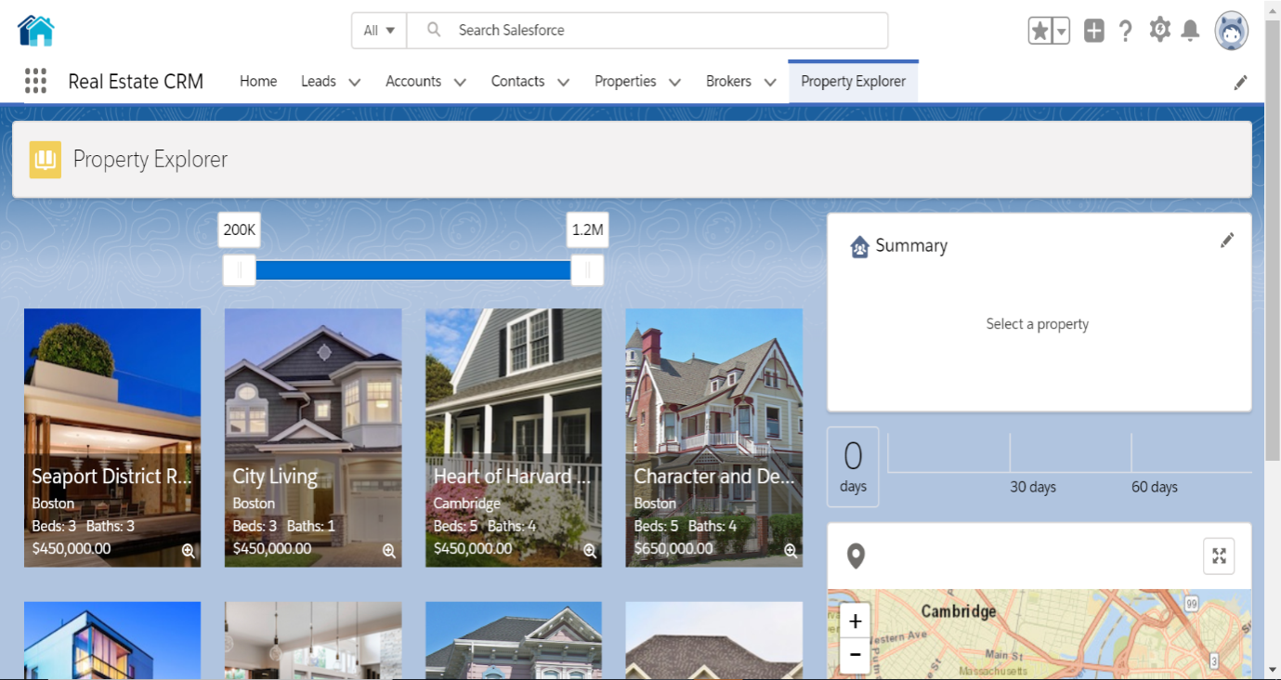

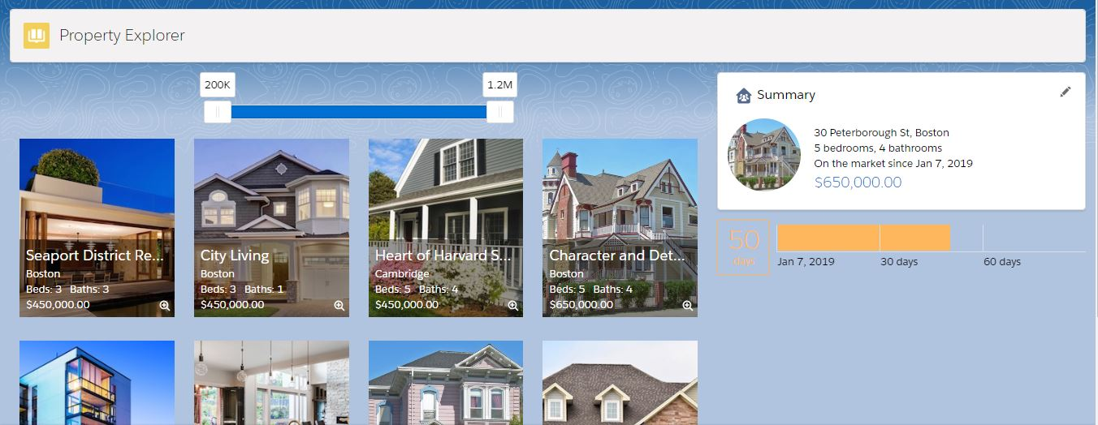

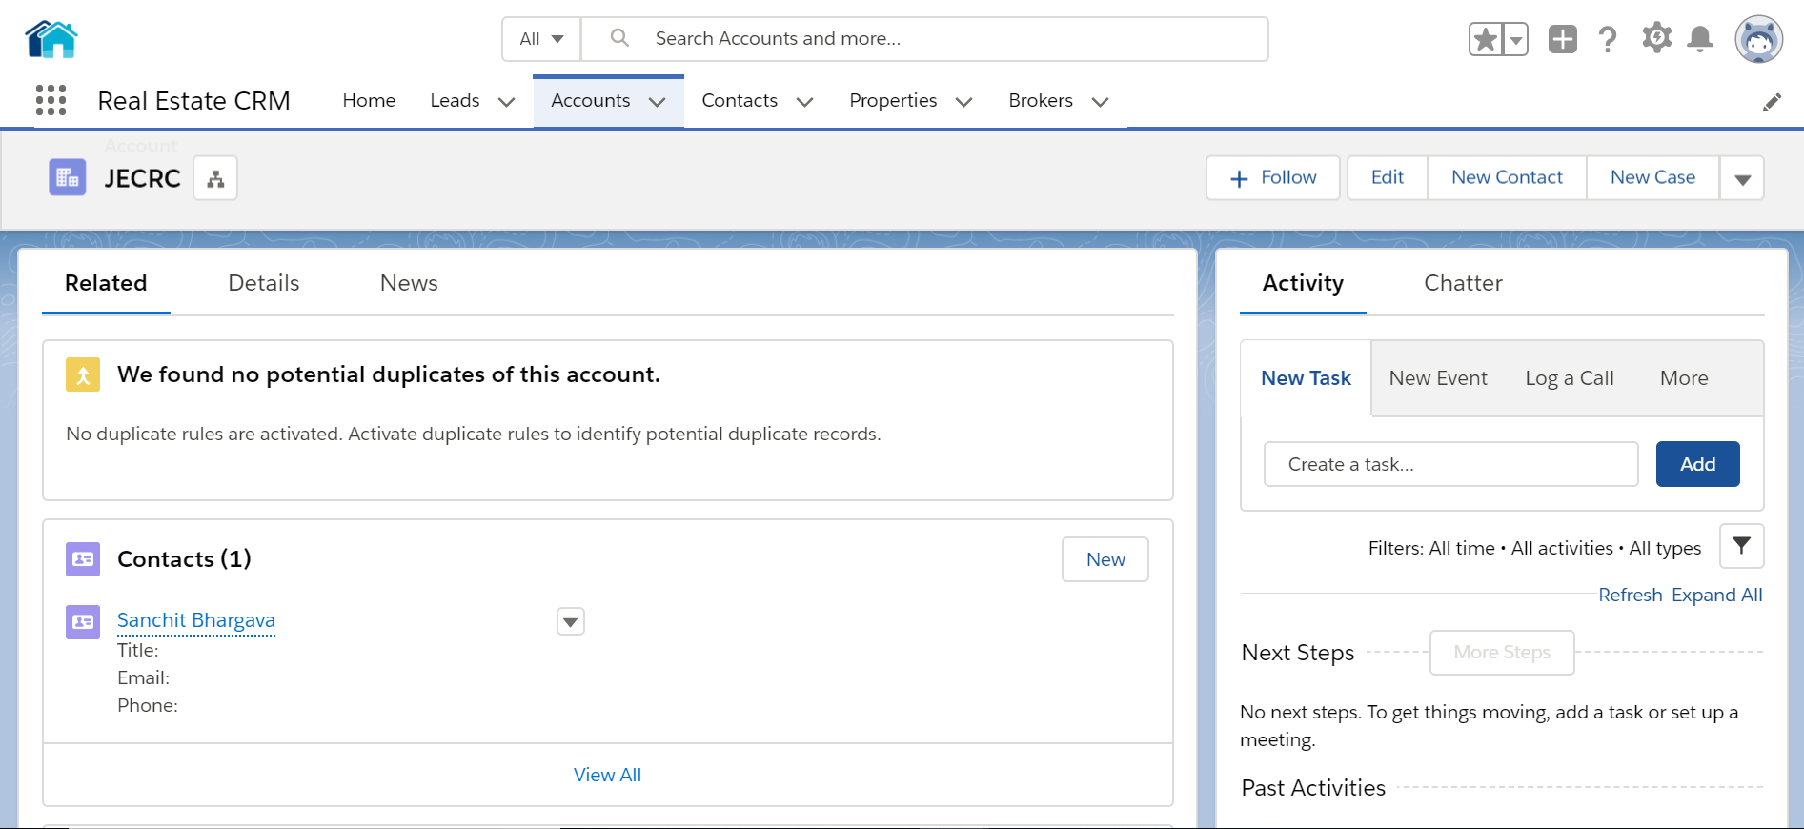

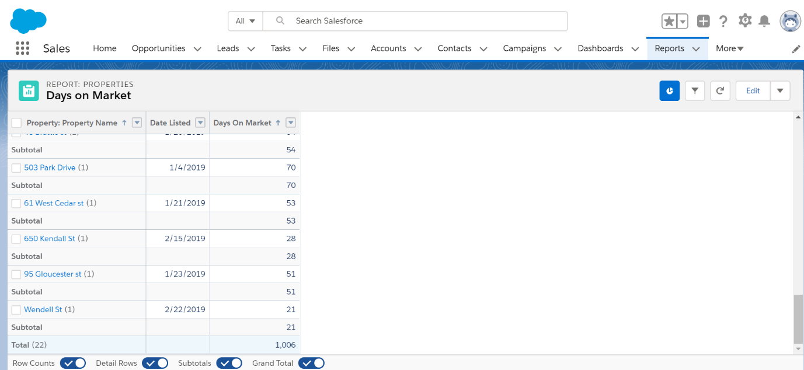

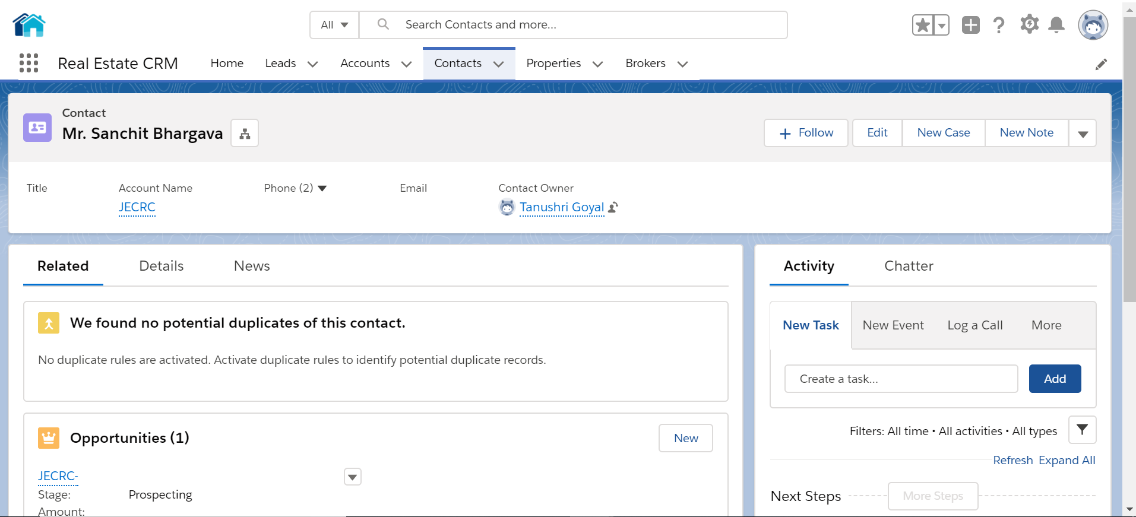

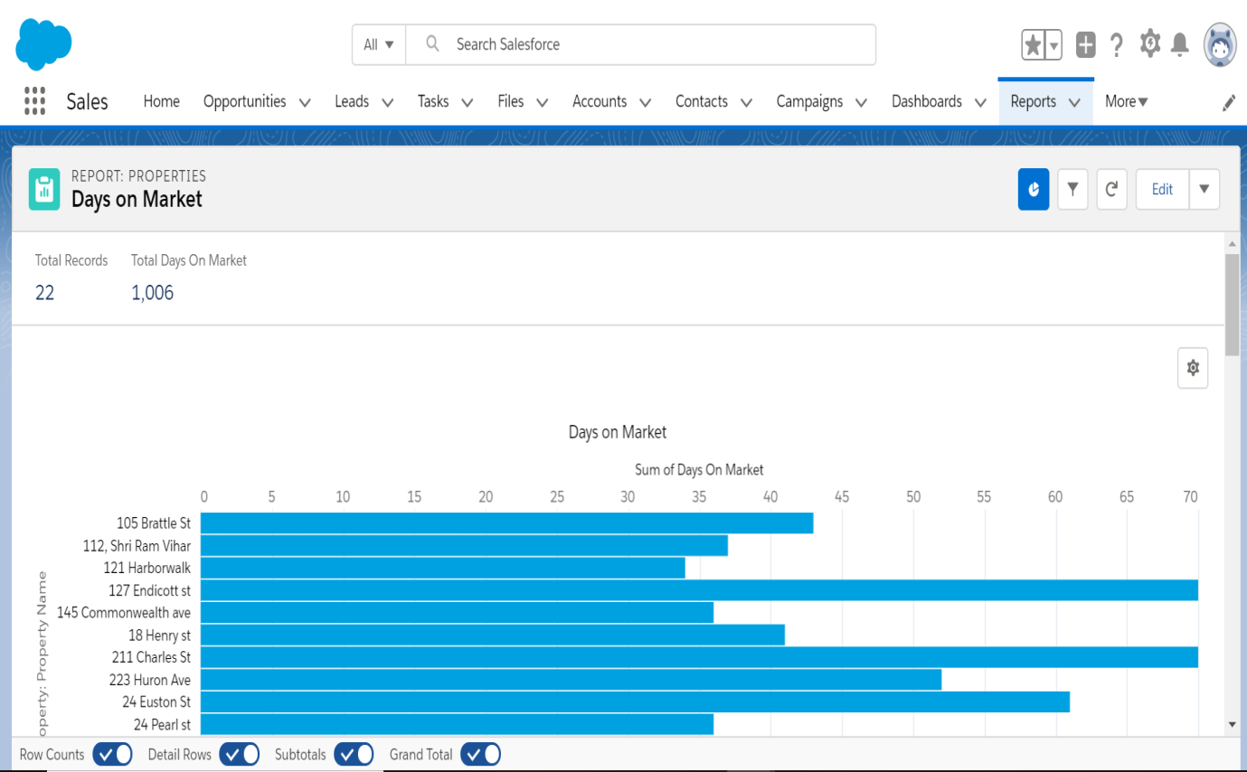

**CONCLUSION**

This project provided a good knowledge in Salesforce and the ways it can be implemented in Real Estate CRM. It is Cost Effective and have a Single Click Calling Availabilities have a Mobile CRM accessibility and also 24/7 Availability and Customer Support

We have learnt about handling procedures in “cloud service model”**.** It also provides us the knowledge about latest technology that has been used in developing web enabled applications and client server technology that will be a great demand in future. This will definitely provide better opportunities and guidance in future in developing projects independently in cloud computing.

**FUTURE SCOPE**

The real of CRM have spread across millions of households, so naturally, Internet has become by far the best platform for real estate marketing today. Now a days when everything is online, how is it possible that real estate left web application behind? There are lots of real estate companies who advertise their property online so idea behind developing this application is that their property can also sell, or buy or even rent property using this. These applications are not widely popular but in future, they have large scope of growth. This CRM is an online real estate management through which individual agents or buyer can maintain their property document keeping and managing property registration and also access its information and manage all the adding, updating, deleting the ads and some of its tasks. The Admin user can inform their agents for regarding to property and update the information regarding property and cancellation of property or changing buyer choice.

**REFERENCES**

**WEB SITE FOR REFERENCES:**

www.cyntexa.com

www.shreyshrama.com

www.salesforce.com/in/solutions/industries

[www.salesforce.com/fincance](http://www.salesforce.com/fincance)

<https://trailhead.salesforce.com>

**REFERENCE BOOKS REFERRED:**

• Lightning Platform Fundamentals

• Lightning Components Developer Guide

• Visual Force in Practice

**MAPPING OF COURSE OUTCOMES (CO) WITH PROGRAM OUTCOMES (PO)**

**Program Outcomes**

1. **Engineering Knowledge:** Apply the knowledge of mathematics, science, engineering fundamentals, and an engineering specialization to the solution of complex engineering problems in IT.
2. **Problem analysis:** Identify, formulate, research literature, and analyze complex engineering problems reaching substantiated conclusions using first principles of mathematics, natural sciences, and engineering sciences in IT.
3. **Design/development of solutions:** Design solutions for complex engineering problems and design system components or processes that meet the specified needs with appropriate consideration for the public health and safety, and the cultural, societal, and environmental considerations using IT.
4. **Conduct investigations of complex problems:** Use research-based knowledge and research methods including design of experiments, analysis and interpretation of data, and synthesis of the information to provide valid conclusions using IT.
5. **Modern tool usage:** Create, select, and apply appropriate techniques, resources, and modern engineering and IT tools including prediction and modeling to complex engineering activities with an understanding of the limitations in IT.
6. **The engineer and society:** Apply reasoning informed by the contextual knowledge to assess societal, health, safety, legal and cultural issues and the consequent responsibilities relevant to the professional engineering practice using IT.
7. **Environment and sustainability:** Understand the impact of the professional engineering solutions in societal and environmental contexts, and demonstrate the knowledge of, and need for sustainable development in IT.
8. **Ethics:** Apply ethical principles and commit to professional ethics and responsibilities and norms of the engineering practice using IT.
9. **Individual and team work:** Function effectively as an individual, and as a member or leader in diverse teams, and in multidisciplinary settings in IT.
10. **Communication:**  Communicate effectively on complex engineering activities with the engineering community and with society at large, such as, being able to comprehend and write effective reports and design documentation, make effective presentations, and give and receive clear instructions.
11. **Project Management and finance:** Demonstrate knowledge and understanding of the engineering and management principles and apply these to one’s own work, as a member and leader in a team, to manage IT projects and in multidisciplinary environments.
12. **Life –long Learning:** Recognize the need for, and have the preparation and ability to engage in independent and life-long learning in the broadest context of technological changes needed in IT.

**8ITPR PROJECT STAGE-II**

**Course Outcomes (COs):**

On completion of the course:

CO1: Graduates will be able to understand the concepts of real-world complex problems with analysing social impact for sustainable development in IT.

CO2: Graduates will be able to apply design, development and testing methodologies.

CO3: Graduates will be able to create cost effective solutions in multidisciplinary environments.

CO4: Graduates will be able to demonstrate their work with writing effective reports and design documentation via presentation tools.

|  |  |  |  |  |  |  |  |  |  |  |  |  |  |  |  |  |  |  |  |  |  |  |  |  |  |  |  |  |  |  |  |  |  |  |  |  |  |  |  |  |  |  |  |  |  |  |  |  |  |  |  |  |
| --- | --- | --- | --- | --- | --- | --- | --- | --- | --- | --- | --- | --- | --- | --- | --- | --- | --- | --- | --- | --- | --- | --- | --- | --- | --- | --- | --- | --- | --- | --- | --- | --- | --- | --- | --- | --- | --- | --- | --- | --- | --- | --- | --- | --- | --- | --- | --- | --- | --- | --- | --- | --- |
|  |  | |  |  |  |  |  |  |  |  | **L /** |  |  |  |  |  | **PO** |  |  | **PO** |  |  | **PO** |  |  | **Po** |  |  | **PO** |  |  | **PO** |  |  | **PO** |  |  | **PO** |  |  | **PO** |  |  | **PO** |  |  | **PO** |  |  | **PO** |  |  |
|  | **SEM** | |  |  | **SUBJECT** |  |  | **CODE** |  |  | **T/** |  |  | **CO** |  |  |  |  |  |  |  |  |  |  |  |  |  |  |  |  |  |  |  |  |  |  |  |  |  |  |
|  |  |  |  |  |  |  |  |  |  |  | **1** |  |  | **2** |  |  | **3** |  |  | **4** |  |  | **5** |  |  | **6** |  |  | **7** |  |  | **8** |  |  | **9** |  |  | **10** |  |  | **11** |  |  | **12** |  |  |
|  |  | |  |  |  |  |  |  |  |  | **P** |  |  |  |  |  |  |  |  |  |  |  |  |  |  |  |  |  |  |  |  |  |  |  |  |  |  |  |  |  |
|  |  | |  |  |  |  |  |  |  |  |  |  |  |  |  |  |  |  |  |  |  |  |  |  |  |  |  |  |  |  |  |  |  |  |  |  |  |  |  |  |  |  |  |  |  |  |  |  |  |  |  |
|  |  | |  |  |  |  |  |  |  |  | **P** |  |  | Graduates will be able to understand the concepts of real world complex problems with analysing social impact for sustainable development in IT. | |  | M |  |  | M |  |  | M |  |  | M |  |  | H |  |  | **M** |  |  | **H** |  |  | **L** |  |  | M |  |  | M |  |  | L |  |  | **H** |  |  |
|  |  | |  |  |  |  |  |  |  |  |  |  |  |  | |  |  |  |  |  |  |  |  |  |  |  |  |  |  |  |  |  |  |  |  |  |  |  |  |  |  |  |  |  |  |  |  |  |  |  |  |  |
|  |  | |  |  | **Project Stage-II** | |  |  |  |  | **P** |  |  | Graduates will be able to apply design, development and testing methodologies. | |  | **M** |  |  | **L** |  |  | **H** |  |  | **H** |  |  | **H** |  |  | **H** |  |  | **M** |  |  | **M** |  |  | **M** |  |  | **H** |  |  | **M** |  |  | **H** |  |  |
|  |  | |  |  |  |  |  |  |  |  |  |  |  |  |  |  |  |  |  |  |  |  |  |  |  |  |  |  |  |  |  |  |  |  |  |  |  |
|  | **7th** | | |  |  |  |  |  |  |  |  |  |  |  |  |  |  |  |  |  |  |  |  |  |  |  |  |  |  |  |  |  |  |  |  |  |  |  |  |  |  |  |  |  |  |  |  |  |  |  |
|  |  |  |  |  | **8ITPR** | |  | **P** |  |  | Graduates will be able to create cost effective solutions in multidisciplinary environments. | |  | **M** |  |  | **M** |  |  | **M** |  |  | **M** |  |  | **H** |  |  | **H** |  |  | **H** |  |  | **H** |  |  | **M** |  |  | **M** |  |  | **M** |  |  | **H** |  |  |
|  |
|  |
|  |
|  |
|  |  |  | |  |  |  |  |  |  |  |  |  |  |  |  |  |  |  |  |  |  |  |  |  |  |  |  |  |  |  |  |  |  |  |  |  |  |  |  |
|  |  |  | |  |  |  |  |  |  |  |  |  |  |  | |  |  |  |  |  |  |  |  |  |  |  |  |  |  |  |  |  |  |  |  |  |  |  |  |  |  |  |  |  |  |  |  |  |  |  |  |  |
|  |  |  | |  |  |  |  |  |  |  |  |  |  |  |  |  |  |  |  |  |  |  |  |  |  |  |  |  |  |  |  |  |  |  |  |  |  |  |  |  |  |  |  |  |  |  |  |  |  |  |  |  |
|  |  |  | |  |  |  |  |  |  |  | **P** |  |  | Graduates will be able to demonstrate their work with writing effective reports and design documentation via presentation tools. |  | **L** |  |  | **L** |  |  | **L** |  |  | **L** |  |  | **M** |  |  | **L** |  |  | **L** |  |  | **L** |  |  | **M** |  |  | **H** |  |  | **L** |  |  | **M** | H |  |  |

**Detailed description of the mapping:**

1. **Engineering Knowledge:** Applied the knowledge of database made an entity relationship diagram to integrate it with schema builder. Applied engineering skills to implement real life scenarios faced in Institute Management.
2. **Problem analysis:** Management of an Institute business data to effectively meet sales targets which lead to business growth.
3. **Design/development of solutions:** Every business if managed effectively helps to improve sales; Salesforce CRM is all about it.
4. **Conduct investigations of complex problems:** Data modelling to keep track of institute data, student registration done by help desk or hod, sending emails upon successful registration of students, designing reports and dashboards for senior staff as well as sales representatives to meet the assigned targets of the institute.
5. **Modern tool usage:** Used Salesforce CRM as it is on boom in the business and IT market, it has been termed as the No. 1 CRM in the world. Top notch companies use salesforce to manage their business.
6. **The engineer and society:** Applied engineering knowledge in real life scenarios a business faces to increase sales and manage the business data. A solution to major problems faced in an institute. A CRM can be easily used by any business to manage data.
7. **Environment and sustainability:** It are built on a Salesforce CRM hence does not require maintenance as salesforce updates itself as it is on cloud and retains the older versions if possible. Being built on salesforce means if the company plans to shut down its servers the project is of no use.
8. **Ethics:** Sticked to the norms of making a project according to the software development cycle with requirement analysis to implementation and testing.
9. **Individual and team work:** Divided the project in various parts and assigned each member a task to be completed in a limited timeframe and each part was discussed with the team before progressing further.
10. **Communication:** Took help from project mentors, salesforce industry experts and institutes as well as they are our end users in planning, designing, implementation and testing of the entire project.

1. **Project Management and finance:** Each one of us took roles as a leader and a team player in various parts of the project. The tiniest implementation of the project was highly well thought with requirements and ways we can ease a business management and help increase sales. The entire project is built with the software development cycle well thought and implemented.
2. **Life –long Learning:** Learnt data modelling and to completely customize the salesforce CRM to implement the real-life scenarios faced in any business.

**TANUSHRI GOYAL SANCHIT BHARGAVA**

**(15EJCIT085) (15EJCIT070)**

**RAHUL SONI MANISHA SEKHAWAT**

**(15EJCIT060) (15EJCIT301)**